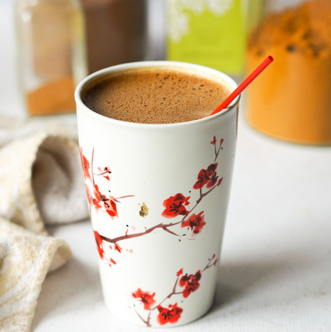
Matcha Maca Choco Latte

Ingredients
1 tbsp Cacao powder, raw
1 tsp Matcha powder
1 tsp Maca powder
1/2 tsp Cinnamon
1/2 tsp Maca powder
1/2 tsp powdered Ginger
1 tbsp Coconut oil
1 cup almond, hemp or coconut milk
2 Tbsp coconut cream for extra creaminess
1 ½ Tbsp raw honey, maple syrup or other sweetener to taste
Method
Heat nut milk, coconut cream and honey. Add powdered ingredients and whisk or blend in a blender. Enjoy hot or chilled on ice

